**CSS 490 PROGRAM 5: REPORT**  
Chandler Ford and Jake Cho | December 2018

**URL Location**  
<https://program5.azurewebsites.net>

**List of Services**

1. Azure Blob Storage
2. Azure Table Storage
3. Azure App Services (Website Hosting)
4. Consuming RESTFUL API (OMDb API)
5. Azure Media Services/Player
6. Bitbucket (Development)

**Clear Design Diagrams**

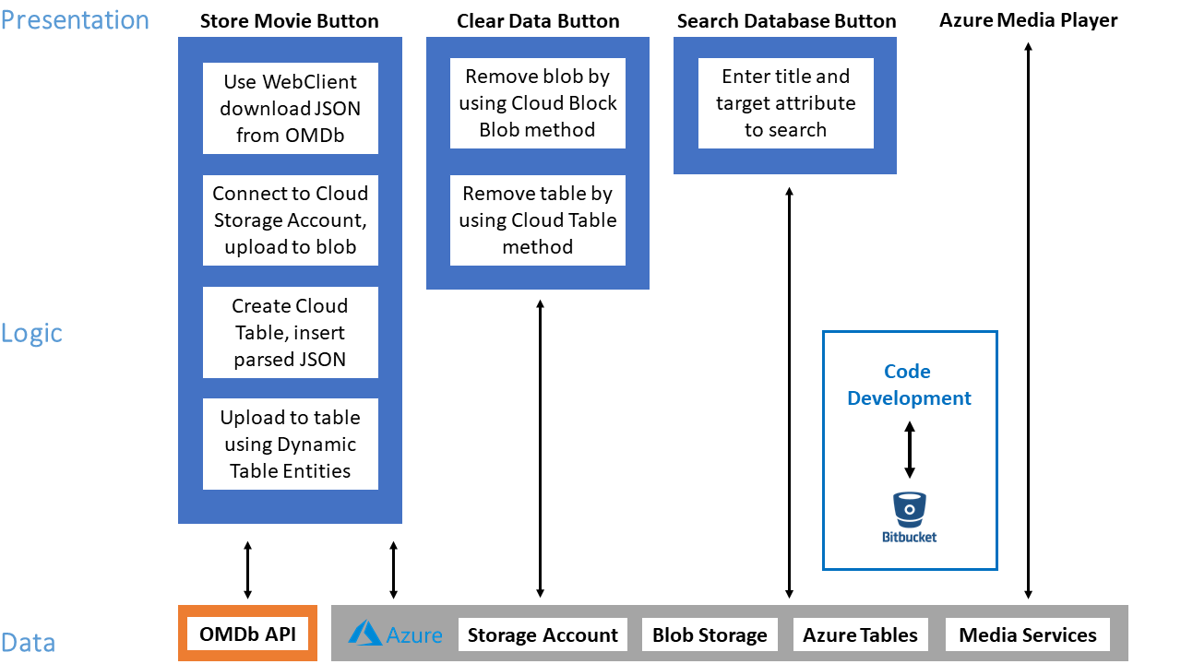

**Cloud Choice Explanation**

We chose Azure over AWS because C# and Visual Studio have a good selection of Azure libraries, features, and documentation that make programming easier. Publishing a Web App from Visual Studio to Azure, for example, is a straightforward process as Visual Studio has a useful Cloud Explorer feature. After the initial setup we were able to simply right click our project name in the Solution Explorer, select publish, and then push the ‘Publish’ button to deploy code our Web App.

**Monitoring and Alerting**

We monitor the system for availability primarily through the Azure Portal. We set up Application Insights for our Web App and created a test in the Availability tab that pings the URL from multiple locations. The test occurs every 15 minutes. If three of the five locations fail in five minutes an alert will be sent out to an email address.

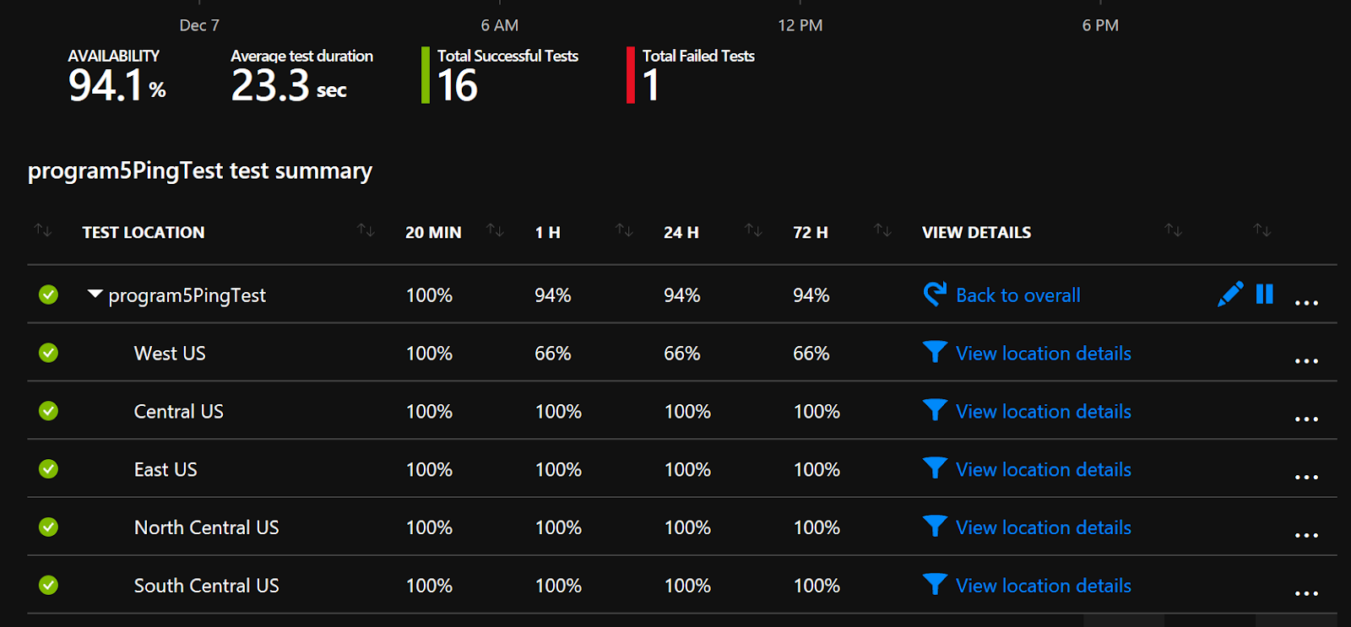

**SLA Discussion**

We have a blob in a storage account which gets **99%** availability. We also utilize Azure Tables in our storage account (again **99%** availability).

Our website is an App Service utilizing the Free tier of Azure. Microsoft states that “No SLA is provided for Apps under either the Free or Shared tiers”. Customers above those tiers are guaranteed 99.95% availability.

There is no SLA provided for the OMDb API we consume. Azure Media Services has **99.9%** for the SLA, while Bitbucket has no official SLA.

Based off the three SLAs that we have we can calculate an estimate SLA:

**99%** * **99%** * **99.9%** = **97.9%**

**Scalability Discussion**

If our site became popular it wouldn’t auto scale out because the ‘Free’ tier of Azure doesn’t support that feature. As far as scaling up goes, according to our App Service Plan each instance of our Web App has a shared infrastructure, 1 GB of memory, and is limited to 60 minutes of dedicated computing resources per day. The Web App also uses the free tier for the OMDb API, which limits the number of data requests to 1,000 per day, which would need to be upgraded accordingly with the increased usage of the web app.

**Sources**

For SLA: <https://azure.microsoft.com/en-us/support/legal/sla/summary/>  
For scaling: <https://azure.microsoft.com/en-us/pricing/details/app-service/windows/>